0-APR-2007: OcucoRelcon Announces Acquisition of OpticBox
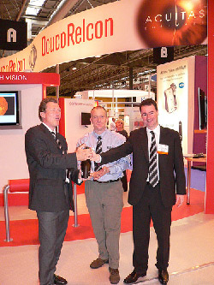
OcucoRelcon acquired Timebox Solutions today for an undisclosed sum. OpticBox from TimeBox now joins Acuitas and Focus in OcucoRelcon’s practice management system portfolio.
OcucoRelcon provides F.O.C.U.S.™ and Acuitas™ practice management systems to opticians of all sizes all over all over the UK and Ireland, with over 1,000 supported sites. Through its subsidiary DRS, it also sells the market leading laboratory management systems to UK and Irish labs, LabMan. ‘This is a very exciting move for both companies’, commented OcucoRelcon’s CEO Al Chetwode. ‘The OpticBox development philosophy has been very similar to our own – focussed on tangible benefits. We expect to achieve synergies through access to a larger product base and the deep well of experience Chris brings to the team.’While the market is still seeing new entrants, the more established software players are consolidating. Chris Van Buren, MD of OpticBox comments ‘It is a finite market – there only so many independent practices in the UK, and that means there can only be a few successful suppliers.
This acquisition of OpticBox, the recent merger between Ocuco and Relcon, the acquisition of DRS Computing last year, mean that we will definitely be one of them.’‘Practice Management Systems, although they must be easy to use, behind the scenes they have to be quite complex. Issues such as VAT apportionment, spectacle deposits and NHS payments are unique to opticians, and these are all issues that have and will continue to catch out developers.’Leo MacCanna comments “Now that Chris Van Buren has joined us, we have a additional experienced optical management to add to our growing resource base and to reflect in the quality of our products, and customer satisfaction levels’.

